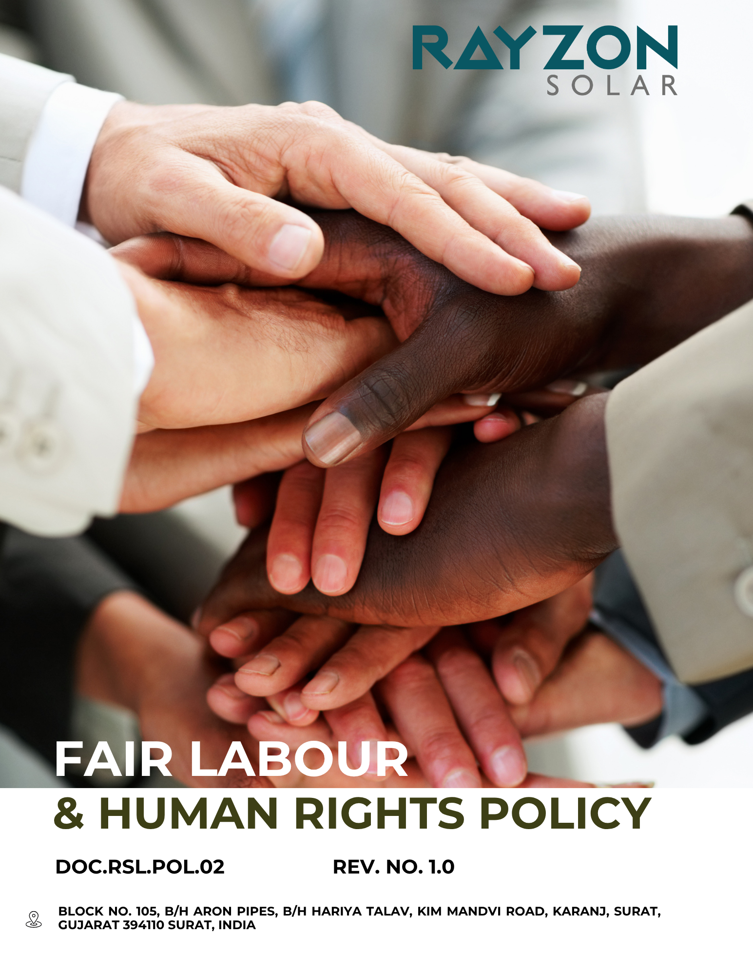
FAIR LABOUR & HUMAN RIGHTS POLICY
Rayzon Solar Ltd.
Effective: April 2024
Approved by the General Manger

Introduction
At Rayzon Solar Ltd., we uphold the dignity, rights, and well-being of every individual connected to our operations and supply chain. Our Fair Labor and Human Rights Policy reflects our unwavering commitment to ethical labor practices, non-discrimination, and respect for fundamental human rights. We strive to create a safe, inclusive, and empowering workplace where all employees and partners are treated fairly, paid equitably, and protected from any form of abuse, harassment, or forced labor. Through continuous monitoring, responsible sourcing, and transparent engagement, we aim to foster an environment rooted in integrity, accountability, and social justice.
We also collaborate with suppliers to ensure human rights due diligence, prohibit exploitative practices such as child labor, and provide clear grievance channels. Our approach emphasizes proactive awareness-building, capacity development, and long-term partnerships that promote fair treatment and shared value across the value chain.

Purpose
- To uphold and protect the fundamental rights of all employees, contractors, and workers across our operations and supply chain.
- To prevent all forms of forced labor, child labor, discrimination, and harassment.
- To ensure fair wages, working hours, and safe working conditions in alignment with national and international labor standards.
- To promote diversity, equity, and inclusion in all employment practices.
- To foster transparent grievance redressal mechanisms and protect whistle-blowers.
- To engage and collaborate with suppliers on human rights due diligence and ethical practices.
- To build a socially responsible culture that respects human dignity and promotes continuous improvement.
- To align company practices with the UN Guiding Principles on Business and Human Rights and the International Labour Organization (ILO) standards.
- To conduct regular assessments and audits to monitor labor and human rights performance internally and across the supply chain.
- To raise awareness and provide training to employees and suppliers on labor rights and ethical work practices.
.Scope
This policy applies to Factory – 1 (Kim site) of Rayzon Solar Ltd., including all employees, departments, contractors, subcontracted workers, directors, and governance bodies operating within this site. It also extends to any affiliated units or functions directly linked to Factory – 1, as applicable.

Rayzon Solar Limited | Factory – 1 | Block No. 105, B/H Aron Pipes, B/H Hariya Talav, Kim Mandvi Road, Karanj, Surat, Gujarat -394110, India.

Our Commitments and Objectives
Company is committed to upholding the highest standards of fair labor practices and human rights across all aspects of our operations and supply chain. We strive to foster a respectful, inclusive, and safe work environment that values the dignity and well-being of every individual. Our efforts go beyond legal compliance and aim to actively promote social equity and ethical conduct.
Our commitments include, but are not limited to, the following focus areas:
- Workplace Safety and Wellness
- We aim to foster a strong safety-first culture through continuous leadership involvement, open employee participation, and strict zero-tolerance for all unsafe practices across all departments.
- We strive to ensure that our facility maintain full compliance with relevant national and international occupational health and safety (OHS) standards without exception.
- We aim to identify and mitigate all potential workplace hazards proactively through timely risk assessments, internal audits, and detailed root cause analysis mechanisms.
- We plan to integrate mental health and emotional well-being into our safety framework by offering targeted programs, counselling services, and awareness campaigns firm-wide.
- We strive to enhance emergency preparedness by organizing periodic fire drills, ensuring that employees are confident in evacuation and response procedures.
- We are committed to providing high-quality, job-specific PPE to all employees and ensuring its proper use through regular monitoring and training.
- We aim to provide regular employee health and safety training to all of our employees, ensuring they remain informed, prepared, and compliant with evolving workplace safety standards.
- Equal Opportunity, Discrimination and harassment
- We will implement transparent and merit-based recruitment, appraisal, and promotion systems to uphold equal opportunity at all levels.
- We aim to foster a zero-tolerance environment toward any form of discrimination or harassment by ensuring prompt, confidential, and impartial redressal for all reported incidents.
- We plan to conduct regular training sessions on anti-discrimination and respectful workplace behaviour for all employees, including managers and supervisors.
- We aim to review and update our HR policies annually to align with the latest national and international standards on equality and non-discrimination.
- We aim to do Partnership with organizations specializing in DEI (Diversity, Equity, and Inclusion) to enhance our recruitment strategies.
- We aim to maintain a transparent and accessible grievance mechanism that ensures timely resolution of discrimination and harassment complaints with complete confidentiality and fairness.
- Employee Growth and Career Development
- We are committed to implementing structured career development programs that support continuous employee growth and foster internal advancement through mentorship, goal alignment, and long-term professional planning.
- We prioritize offering personalized learning paths through digital platforms and expert-led sessions to enhance employee engagement and performance across all departments, functions, and geographic office locations.
- Our goal is to conduct annual skill-gap assessments across all departments to enable targeted and impactful upskilling initiatives that directly support operational efficiency and innovation capacity.
- We endeavor to promote internal mobility and cross-functional exposure to build a versatile and future-ready workforce capable of adapting to new roles and emerging technologies.
- We ate focused on recognizing and rewarding skill development achievements to drive motivation and strengthen employee retention through structured recognition programs and career progression plans.
- We intend to collaborate with external institutions and professional trainers to deliver industry-relevant learning opportunities that are updated annually to reflect evolving solar industry trends.
- We plan to offer regular training and development programs to help employees grow their skills and build strong careers within the company.
- Fair Wages and Benefits
- We strive to ensure fair, competitive, and transparent compensation practices by regularly benchmarking wages, eliminating pay disparities, and aligning with industry and living wage standards.
- We aim to provide a comprehensive and inclusive benefits package that supports employee well-being through healthcare, leave policies, retirement plans, and performance-linked incentives.
- We plan to promote awareness and accessibility of wage-related rights and benefits by maintaining open communication, conducting periodic reviews, and offering training on compensation entitlements.
- Working Condition
- We are committed to maintaining clean, well-ventilated, and ergonomically optimized workspaces that promote employee well-being, operational efficiency, and sustained productivity.
- We ensures that all facilities are proactively inspected, maintained, and upgraded to eliminate safety risks and maintain an organized, hazard-free work environment.
- We guarantee uninterrupted access to safe drinking water, hygienic sanitation facilities, and comfortable break areas at all operational locations to uphold employee dignity and well-being.
- We uphold fair scheduling practices by enforcing regulated working hours and limiting excessive overtime, in full compliance with the Factories Act, 1948, and all applicable Indian labor laws, to support work-life balance and employee health.
- We maintain optimal environmental conditions—including adequate lighting, acoustics, and temperature controls—to reduce workplace stress and enhance comfort, safety, and focus throughout the workday.
- Dedicated infrastructure is provided for women employees, including secure changing areas, maternity care facilities, and gender-sensitive amenities to foster an inclusive and supportive workplace.
- We aim to provide comprehensive health insurance coverage to all eligible employees to ensure financial security and promote physical and mental well-being.
- We are committed to full compliance with all applicable labor laws and internationally recognized standards, including ILO Conventions and the UN Guiding Principles on Business and Human Rights, to uphold safe, equitable, and legally compliant working conditions.
- Social Dialogue
- We are committed to fostering structured and transparent social dialogue by formally recognizing employee representatives to facilitate mutual understanding and cooperation.
- We plans to institutionalize quarterly town hall meetings to discuss employee concerns, share company updates, and strengthen organizational transparency.
- We aim to maintain open, ongoing communication channels between management and employees through scheduled dialogue sessions, committee meetings, and digital platforms that support collective participation.
- The company strives to establish and support employee welfare committees or representative forums where concerns, suggestions, and feedback can be regularly discussed and resolved collaboratively.
- We plan to promote the role of elected employee representatives by providing them with clear responsibilities, access to relevant information, and the training needed to fulfil their functions effectively.
- We ensures that all employees have the freedom to associate and engage in collective bargaining, in accordance with Indian labor laws and ILO Conventions, without fear of retaliation or discrimination.
- We are committed to developing a formal grievance resolution channel in consultation with employee representatives, ensuring fair and participatory handling of workplace concerns.
- Ethical Labor Practices and Safeguards
- Rayzon strictly prohibits all forms of child labor, forced labor, and human trafficking and remains fully committed to protecting human dignity across all operations.
- We plan to implement strong age verification and identity validation procedures during the hiring process to ensure no underage individuals are employed.
- The company aims to conduct regular internal assessments and risk audits to identify, prevent, and eliminate any instance of forced or involuntary labor practices.
- We strive to ensure every employee receives a clear and voluntary employment contract outlining rights, duties, wages, and terms of engagement in a transparent manner.
- We plan to deliver regular training sessions for HR personnel, recruitment teams, and managerial staff to strengthen their ability to detect, prevent, and respond to risks related to child labor, forced labor, and human trafficking.
- We aim to maintain anonymous, safe, and accessible grievance channels where employees or stakeholders can report unethical labor practices without retaliation.
- The organization plans to engage with relevant stakeholders, including NGOs, labor rights groups, and regulatory bodies, to stay aligned with international standards and legal frameworks such as ILO Conventions and the UN Guiding Principles on Business and Human Rights.
- We are committed to continuously updating our labor and recruitment policies to reflect best practices and emerging risks related to modern slavery and human exploitation.
- Rayzon pledges to take prompt disciplinary and legal action against any internal violations of its zero-tolerance approach to child labor, bonded labor, or trafficking.

Quantitative Targets

All of the below quantitative targets are measured against the baseline year FY 2022–23, which serves as the reference point for tracking progress across our sustainability performance areas.
- Workplace Safety and Wellness
- Our target is to ensure 100% of employees receive annual health and safety training by FY 2027–28.
- We aim to conduct at least two fire drills per site every year to reinforce emergency preparedness.
- Our goal is to achieve full compliance (100%) with PPE usage across all operational
- We commit to carrying out quarterly health and safety risk assessments at every operational location.
- We target to provide annual preventive health check-ups to at least 95% of our full-time workforce by FY 2027-28.
- Our goal is to maintain 100% availability of first aid kits and emergency response equipment across facility.
- We aim to maintain zero reported health and safety violations or major incidents through FY 2027–28, continuing our clean record from previous years.
- Equal Opportunity, Discrimination and harassment
- Our aim is to maintain 100% zero-tolerance enforcement against any reported cases of discrimination or harassment.
- We plan to conduct mandatory anti-discrimination and unconscious bias training for 100% of employees every year.
- Our target is to achieve at least 50% female representation in mid and senior-level office roles by FY 2027–28.
- We strive to resolve all reported discrimination or harassment complaints within 7 working days of receipt.
- We commit to having at least one trained internal complaints committee (ICC) at every site by FY 2027–28.
- We plan to review and update the Equal Opportunity Policy and POSH framework annually.
- Our target is to conduct biannual internal audits of discrimination and harassment procedures across all departments.
- Employee Growth and Career Development
- We aim to ensure that 100% of employees receive at least one career development discussion annually by FY 2027–28.
- Our target is to provide role-based skill development training to at least 95% of employees by FY 2027–28.
- We strive to achieve a minimum 85% employee satisfaction score in annual surveys related to career growth and learning opportunities by FY 2027–28.
- Our goal is to roll out individual development plans (IDPs) for all employees by FY 2026–27 and track their implementation by FY 2027–28.
- We plan to launch a formal mentorship program and achieve 70% employee participation by FY 2027–28.
- We commit to investing at least 3% of the annual payroll budget into learning and development programs by FY 2027–28.
- We intend to deliver a minimum of 20 hours of learning and development per employee annually by FY 2027–28.
- Our aim is to assess and update all training content annually to align with emerging industry skills and technology demands by FY 2027–28.
- Fair Wages and Benefits
- Ensure that 100% of employees receive wages equal to or above the applicable legal minimum wage and sectoral standards by FY 2027–28.
- Achieve full compliance in providing statutory benefits (PF, ESI, gratuity, paid leave, etc.) to 100% of eligible employees by FY 2027–28.
- Conduct annual third-party wage audits to ensure pay equity and benefit entitlements are met.
- Ensure that gender pay gap, if any, is measured and addressed annually, targeting 0% gender-based pay disparities by FY 2027–28.
- Working Condition
- Our goal is to maintain 100% compliance with national labor laws and relevant workplace safety standards across our facilitiy by FY 2027–28.
- We strive to conduct quarterly workplace safety audits at 100% of operational sites by FY 2027–28.
- Our target is to provide ergonomic workstations to 100% of eligible office-based employees by FY 2027–28.
- We plan to ensure that all employees have uninterrupted access to clean drinking water, restrooms, and hygienic break areas by FY 2027–28.
- We commit to providing comprehensive health insurance to 100% of full-time employees by FY 2027–28.
- We intend to achieve 100% participation in annual fire safety and emergency response drills by FY 2027–28.
- Our objective is to ensure that 100% of working hours are scheduled in compliance with the Factories Act, 1948, and other applicable labor laws by FY 2027–28.
- We aim to install and maintain effective lighting, temperature control, and noise-reduction systems by FY 2027–28.
- We target to conduct biannual employee feedback surveys on working conditions and achieve at least 85% satisfaction rates by FY 2027–28.
- Social Dialogue
- Our aim is to establish recognized employee representation structures at 100% of operational sites by FY 2027–28.
- We target to conduct a minimum of one formal dialogue sessions per year with employee representatives at each site by FY 2027–28.
- We strive to ensure that 100% of employees are informed about their right to collective bargaining by FY 2027–28.
- Our plan is to include employee-elected representatives in all relevant workplace policy consultations by FY 2027–28.
- We aim to maintain 100% transparency and documentation of all social dialogue outcomes and agreements by FY 2027–28.
- We aim to include 100% of employees in the employee representation nomination and election process by FY 2027–28.
- Our goal is to ensure 100% of employees are covered under the Collective Bargaining Agreement, including communication platforms and response protocols, by FY 2027–28.
- We strive to maintain continuity and stability in all collective bargaining agreements, ensuring no disruption in representation or negotiation cycles through FY 2027–28.
- Ethical Labor Practices and Safeguards
- We aim to achieve 100% compliance with legal age verification procedures for all new hires by FY 2027–28.
- Our goal is to conduct annual third-party audits to verify the absence of child labor and forced labor practices across all operations.
- We aim to conduct at least one internal assessment and one comprehensive risk assessment annually to identify, monitor, and mitigate potential issues related to child labor, forced labor, and human trafficking within our operations.
- We strive to provide 100% of HR and recruitment staff with specialized training on detecting and preventing forced labor and human trafficking risks.
- We plan to maintain an anonymous and accessible grievance mechanism covering 100% of employees by FY 2027–28.
- We target zero tolerance incidents reported of child labor, forced labor, or human trafficking in our operations by FY 2027–28.
- We commit to reviewing and updating recruitment and labor policies annually to align with the latest legal and ethical standards.
- We aim to ensure 100% of suppliers and contractors comply with anti-child labor and anti-forced labor policies by FY 2027–28.
- Our goal is to achieve 90% awareness among employees regarding their rights and protections against forced labor and trafficking risks.

Governance, Implementation & Oversight
The Chief Executive Officer holds the ultimate responsibility for ensuring the effective enforcement of this Fair Labor and Human Rights Policy. The daily management and oversight are delegated to the Labor Rights and Compliance Committee, which includes leaders from Human Resources, Operations, and Compliance departments. This committee is tasked with embedding labor rights principles throughout all business functions and maintaining consistent alignment with legal and ethical standards.
Our governance system requires regular reviews of labor practices, audits on employee welfare, and thorough assessments of workplace conditions covering health, safety, remuneration, and equal opportunity. Additionally, labor risk evaluations are integrated into recruitment, supplier selection, and operational processes to ensure full compliance with national laws and international labor conventions. These reviews are conducted quarterly and reported to senior management to promote transparency and foster continuous improvement.

Responsibility of this policy
Designation | Responsibilities
Chief Executive Officer (CEO) | - Provides overall leadership and accountability for policy implementation  - Ensures alignment with company values and legal frameworks  - Reviews performance and leads strategic decision-making
Head of Human Resources | - Leads policy rollout and workforce compliance  - Oversees employee training, grievance handling, and labor rights adherence  - Manages employee relations and reports compliance status
Compliance Officer | - Conducts labor law audits and risk assessments  - Monitors internal compliance and suggests corrective measures  - Prepares compliance reports for senior management
Operations Supervisor | - Implements labor policies on the ground  - Trains and guides employees on workplace standards  - Reports operational compliance and escalates issues
Procurement Manager | - Ensures suppliers comply with labor and human rights standards  - Performs due diligence and audits of supplier labor practices
Employee Relations Officer | - Facilitates communication between employees and management  - Supports grievance resolution and promotes labor rights awareness
All Employees | - Adhere to policy requirements in daily work  - Report violations and support a respectful workplace culture

Reporting
- Internal Monitoring: The Human Resources Lead compiles monthly reports on labor compliance, training, and grievance cases. Quarterly summaries are presented to senior leadership highlighting key findings and areas needing attention.
- Public Disclosure: The organization publishes an annual report on labor rights performance, referencing compliance with global standards such as ILO and UN Guiding Principles, including supplier labor practices.
- Issue Escalation: Significant labor concerns or incidents are escalated to the CEO and the Labor Rights Committee to ensure swift corrective action and policy refinement..

Continuous Improvement
The company dedicates itself to ongoing improvement of labor practices through regular policy reviews, incorporation of emerging best practices, audit feedback, and engagement with stakeholders. Our aim is to foster a workplace culture that respects human dignity, promotes fairness, and meets evolving regulatory expectations.

Policy Alignment with SDGs





Policy Review & Validity
This Fair Labor and Human Rights Policy is effective from the date approved by the General Manager and will remain valid until superseded or revised. A comprehensive policy review will take place at least annually or sooner as necessary due to regulatory or operational changes.
Our organization remains devoted to upholding ethical labor standards and advancing human rights across all areas of operation, ensuring responsible and respectful treatment of all employees and partners.

Last Review date: 01-01-2025 Next Review date: 01-01-2026

Approved by: General Manger

Employee Acknowledgement Form
I confirm that I have received, read, and thoroughly understood the Fair Labor and Human Rights Policy of the company. I acknowledge my responsibility to uphold its principles and fully comply with its requirements at all times. I understand that non-compliance may lead to disciplinary actions, including possible termination. I pledge to contribute positively to a workplace environment that respects labor rights, promotes equality, and upholds human dignity. I commit to promptly reporting any violations, concerns, or unsafe practices to the appropriate channels to support a safe and fair workplace for all.

Employee Name: _____________________
Designation: ________________________
Signature: ___________________________
Date: _______________________________

